Infrastructure as a Service (IaaS)
# Source: AI Source: Provided by: [Data Path: Persons Table -> ID Column: 1, Name_En Column: Motasem Essam] -> From: [ChatGPT] on [1/26/2026]
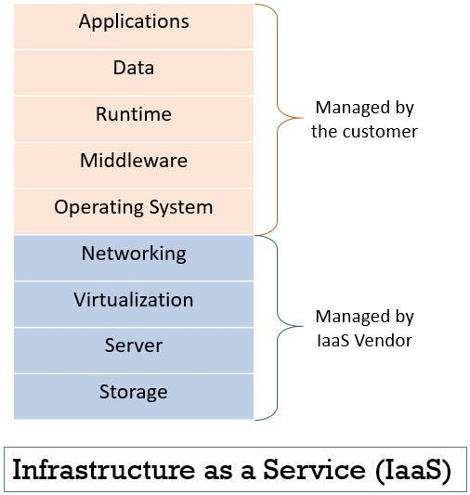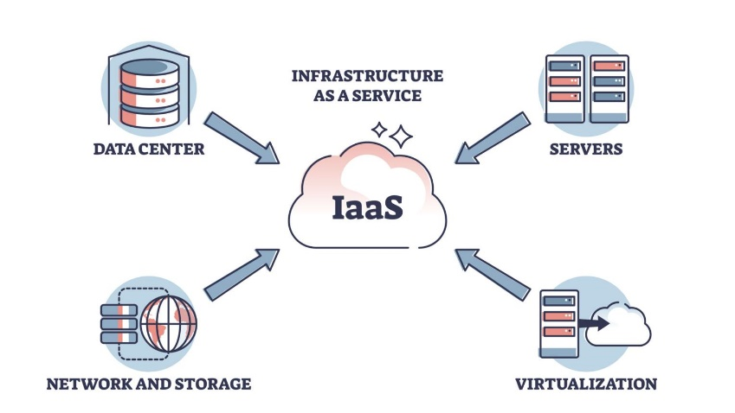
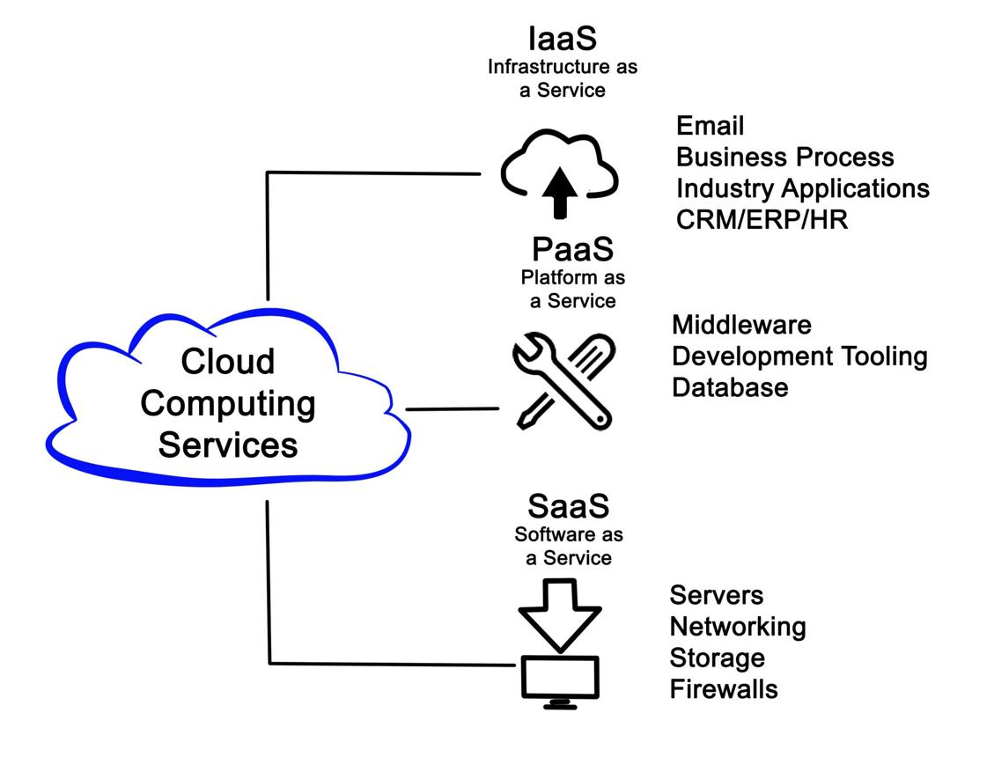
Infrastructure as a Service (IaaS) is a cloud computing model where you rent virtualized computing resources like servers, storage, and networking over the internet.

🧠 Simple Explanation
# Source: AI Source: Provided by: [Data Path: Persons Table -> ID Column: 1, Name_En Column: Motasem Essam] -> From: [ChatGPT] on [1/26/2026]
It’s like renting a computer system online:
- The provider owns and maintains the hardware
- You control how to use it (install OS, apps, etc.)

⚙️ What You Get
# Source: AI Source: Provided by: [Data Path: Persons Table -> ID Column: 1, Name_En Column: Motasem Essam] -> From: [ChatGPT] on [1/26/2026]
- 🖥️ Virtual machines (servers)
- 💾 Storage systems
- 🌐 Networking tools
👉 You manage:
- Operating system
- Applications
- Security settings

🏢 Popular Providers
# Source: AI Source: Provided by: [Data Path: Persons Table -> ID Column: 1, Name_En Column: Motasem Essam] -> From: [ChatGPT] on [1/26/2026]
- Amazon Web Services
- Microsoft Azure
- Google Cloud Platform

🔑 Key Features
# Source: AI Source: Provided by: [Data Path: Persons Table -> ID Column: 1, Name_En Column: Motasem Essam] -> From: [ChatGPT] on [1/26/2026]
- Scalable and flexible
- Pay-as-you-go pricing
- Full control over environment

📦 Example
# Source: AI Source: Provided by: [Data Path: Persons Table -> ID Column: 1, Name_En Column: Motasem Essam] -> From: [ChatGPT] on [1/26/2026]
Hosting a website using a virtual server instead of buying a physical one.

✅ Advantages
# Source: AI Source: Provided by: [Data Path: Persons Table -> ID Column: 1, Name_En Column: Motasem Essam] -> From: [ChatGPT] on [1/26/2026]
- No hardware cost
- Easy scaling
- High flexibility

⚠️ Disadvantages
# Source: AI Source: Provided by: [Data Path: Persons Table -> ID Column: 1, Name_En Column: Motasem Essam] -> From: [ChatGPT] on [1/26/2026]
- Requires technical skills
- You handle maintenance (software side)

📌 Summary
# Source: AI Source: Provided by: [Data Path: Persons Table -> ID Column: 1, Name_En Column: Motasem Essam] -> From: [ChatGPT] on [1/26/2026]
IaaS provides basic cloud infrastructure (servers, storage, networking) on demand, where the provider manages the hardware and you manage everything else.

